Technical Writing

COURSE HANDBOOK

Engl. 321

Engl. 387

Engl. 425/525

Engl. 459

Engl. 487

Dorian Harvey, M.A., M.B.A.

[www.dorianharvey.com](http://www.dorianharvey.com)

[www.dorianharvey.wordpress.com](http://www.dorianharvey.wordpress.com)

|  |  |  |
| --- | --- | --- |
| Dept. of English |  | Dept. of English |
| Minnesota State University |  | North Dakota State University |
| Moorhead, MN |  | Fargo, ND |
|  | Graduate Programs in Software |  |
|  | University of St. Thomas |  |
|  | St. Paul, MN |  |
|  |  |  |

Table of Contents

# Getting Started

Welcome to this online class 1

Read the Course Syllabus with Semester Schedule 1

Print and organize the course files 2

Create web mail folders for class 2

Send me your single best phone number 2

Prepare for our videoconference 3

You’re ready to start! 3

# Formatting Assignments

Overview 5

Identifying yourself 5

Text and headings 6

Page layout 7

# Formal Outlining

Overview 9

Conventions 9

Example 10

Final document 10

# Achieving a Technical Writing Style

Overview 11

Technical writing defined 11

Word choice 12

Document structure and organization 17

Content development 18

Conclusion 20

# Using Your Field’s Citation Style

Overview 21

Using Word’s “Citations & Bibliography” Feature 22

# Creating Basic Visuals

Overview 25

Tables 25

Flowcharts 27

Site maps (hierarchies) 29

# Using Professional E-mail Style

Overview 33

Message recipients’ needs and expectations 34

E-mail checklist 34

# Using Skype

Overview 35

Video tutorials (Windows and Apple users) 35

Step-by-step procedures (Windows users) 35

Creating a Skype account 36

Adding a contact 37

Making a video call 38

# Style and Mechanics Reviews

Finding Help with Basic Grammar and Mechanics 39

Additional Help Online 40

1 Agreement 41

2 Avoiding “There is,” “There are,” and “It is” 45

3 Active and Passive Voice 47

4 Colons and Semicolons 49

5 Parallel Structure 53

6 Misplaced Modifiers 57

7 Hyphenation 59

8 Punctuation and Quotation Marks 61

9 Sentence Combining 63

10 Third-Person Perspective (Avoiding “You”) 67

11 Direct Phrasing 69

12 “That” and “which” 71

# Appendix: Instructor’s Information

Professional background 73

Philosophy of teaching 73

Curriculum Vita 74

Getting Started

# Welcome to this online class!

This introductory document answers the questions, “What do I do?” and “Where do I begin?” With the information here, you’ll gain a clearer idea of how we get things done online, and will be prepared to complete the variety of small tasks assigned for Week 1.

(The two sentences above form this document’s “purpose statement.” You’ll read about purpose statements very soon, and will be writing one for each graded assignment. For now, think of a purpose statement as being similar to an academic thesis statement in location and function, but fundamentally different from a thesis statement in its focus on the reader.)

# ⬜ Read the Course Syllabus with Semester Schedule

Syllabus

Read the course syllabus carefully. While some sections will be familiar to you from other courses, the following sections are unique to our class:

* How to reach me, and the times that I’m available
* Required textbook(s)
* Learning objectives
* Instructional strategies
* Outside help for writing and reading comprehension
* How final grades are calculated

Schedule

The Semester Schedule, printed at the end of the Syllabus, is the official source for assignment due dates.

# ⬜ Print and organize the course files

Print the materials on our course website as they become available. Organize the printed files in a binder, under tabs that match the course website’s organization (e.g., “Content,” “Assignments,” etc.).

Taking the time for this step early in the semester gives you easy access to all of the course materials whenever you need them.

# ⬜ Create web mail folders for class

Create a folder in your e-mail account’s Inbox and Sent folder specifically for this class.

Filing your class-related messages this way will save you considerable time when you want to reread something that you recall having read in an e-mail, or if you want to find a message you sent to me.

# ⬜ Send me your single best phone number

It’s sometimes more efficient to converse over the phone than to exchange ideas through e-mail. For example, if you send me a question about an assignment, I might need more information about your approach to the assignment before I can give you a useful answer.

So, please send *your single best phone number*, and put it in the Subject line of your e-mail only, as shown below:

Engl. XXX: [Name] [phone number]

It helps me tremendously when I can find all of my students’ phone numbers in my inbox view, rather than having to open 22 e-mails per class.

NOTE: I won’t open these messages, so don’t include questions in the body of your note. Instead, write me a second message.

# ⬜ Prepare for our videoconference

We use videoconferences early in the semester to help us feel more engaged with each other and with the course topics. The first videoconference is worth a number of points, so be prepared to discuss your current assignment(s).

To participate in a videoconference, your computer will need a webcam and a microphone. Most late-model laptops have those devices built in, but tower-based desktop computers often don’t.

If you need a webcam, a microphone, or both, you’ll find good-quality, individual and combined devices for about $40 (e.g., see Amazon.com’s selection at <http://www.amazon.com/s/ref=sr_kk_2?rh=i%3Aelectronics%2Ck%3Aweb+camera+with+microphone+for+skype&keywords=web+camera+with+microphone+for+skype&ie=UTF8&qid=1348773414>).

Scheduler

We use Doodle.com to reserve times during conferences week. You’ll find the link for reserving your conference time on the Semester Schedule, in Week 1’s “Assignments Due” column. Instructions for reserving a time are provided on the same page as the reservation times.

Skype.com

We use the website www.Skype.com for videoconferences. If you already have a Skype account, please add me as a contact as soon as possible. To find me, search for my Skype name, dorian-harvey.

If you don’t have a Skype account, follow the procedures in the Using Skype section of this handbook to create your account and to add me as a contact.

# You’re ready to start!

You know enough now to begin Week 1’s tasks. By the end of Week 1, you’ll be familiar with several elements of our class:

* Syllabus and Semester Schedule
* Textbook(s)
* Course website and materials
* Doodle.com scheduler
* Skype.com video-calling site

Formatting Assignments

# Overview

This section describes the steps you can take to create a uniform, professional appearance for your documents this semester. Following these guidelines will not only make your assignments easier for me to read and grade, but also give you practice in creating professional looking documents for the workplace.

# Identifying yourself

Filenames

Save your files with your last name as the first word of the filename. For example,

Schenk Inspection Report Obj. Wksht.

Identification on document’s first page

For most assignments, single-space your name and other identifying information in the upper-left corner of the document’s first page, as shown below.

If an assignment involves a letter or memo of transmittal (also called “cover letter” or “cover memo”) or a title page, you’re already identified on the first page and don’t need to identify yourself further.

Square brackets indicate information that differs according to context. Don’t retain the square brackets after you fill in the information.

[Name]

[Course number]

[Assignment name]

[Date]

# Text and headings

The terms “serif” and “sans-serif” are used below. If you don’t know their definitions, look them up.

Text

Use a common serif font, such as Times New Roman or Palatino, for the body text. Use 11 pt or 12 pt type size.

Heading scheme

Use a common sans-serif font, such as Ariel or Calibri, for headings and subheadings. Use type size and style (e.g., bold) to clearly show the hierarchy of sections and subsections.

Ariel:

Title (16 pt, centered)

Level 1 Heading (16 pt, aligned with left margin)

Level 2 Heading (14 pt, aligned left)

*Level 3 Heading (12 pt., italic, underlined, aligned left)*

*Level 4 Heading (11 pt., italic, aligned left)*

Calibri:

Title (18 pt, centered)

Level 1 Heading (18 pt, aligned with left margin)

Level 2 Heading (16 pt, aligned left)

*Level 3 Heading (14 pt., italic, underlined, aligned left)*

*Level 4 Heading (12 pt., italic, aligned left)*

# Page layout

General spacing

* *Margins:* Use one-inch margins at the top, sides, and bottom.
* *Identification (ID) area:* Single-space the ID area in the upper-left corner of p. 1.
* *Title:* Center the document’s title, and place it a bit lower than the ID area. Use the same type size and style as your document’s level 1 headings.
* *Text:* Double-space the text unless the assignment instructions state otherwise.
* *Headings:* Use more vertical space before headings than after them, so that they are linked visually to the text to which they apply.

Paragraphs

Use either block paragraphs (most common) or first-line-indented paragraphs, and space them accordingly:

* *Block-paragraphs* need extra vertical spacing to appear distinct on the page. The block paragraphing in this *Handbook* demonstrates this extra spacing. Don’t add a whole extra “return,” but instead, increase the paragraph spacing. View a demo at <http://www.gcflearnfree.org/word2010/9.2>.
* *First-line-indented paragraphs* need no additional vertical spacing between them.

Page numbers

Number the pages of documents that are longer than one page, and place page numbers in the document’s footer area. View a demo at <http://www.gcflearnfree.org/word2010/19.1>.

Formal Outlining

# Overview

The formal outline is a universally applicable communication planning tool. Formal outlines are used to communicate within organizations, throughout industries, and between countries.

Individuals use formal outlines to organize ideas before starting a communication. Groups use formal outlines to arrive at agreement on the structure of a document.

In this class, you’ll write formal outlines in the planning documents for graded assignments. Outlines are used for planning, so don’t be concerned if an assignment’s final structure is different from the outline you originally planned to follow.

# Conventions

A formal outline follows established conventions that enable it to communicate across countries, industries, and workplaces. Follow the conventions below as your write your formal outlines for class:

• *Format:* Start the first level of information with Roman numerals, and continue with subsequent levels as shown in the sample in the next section.

• *Structure:* Indent the various levels of the outline toward the right, as shown in the sample in the next section. Use parallel structure in the listed ideas—all noun phrases, all verb phrases, etc. To learn more about parallel structure, read Style and Mechanics Review #5.

NOTE: An idea can’t be divided into just one idea, so be sure to list at least two ideas in each section. If you can’t come up with a second idea, then work the first idea into the level above it.

• *Content:* At a minimum, list your planned headings and subheadings. If possible, include information you know about the sections at this time, remembering that your outline may change as you develop your document.

# Example

The formal outline below shows the conventions of carrying the structure of a formal outline down to the fourth level of detail. Follow these conventions in your own outlines.

# Introduction (includes purpose statement)

# First body section

1. First subsection in this section
2. First subsection in this subsection
3. Second subsection in this subsection
4. Etc.
   1. First subsection in this subsection
   2. Etc.
   3. First subsection in this subsection
   4. Etc.
5. Second subsection in this section
6. Etc.

# Second body section

# Etc.

# Last major section (typically, “Conclusion”)

# Final document

Remove numbering

Remove a formal outline’s section numbering from the final document and from the Table of Contents, if one is used. Headings are numbered only in special-purpose documents that are revised frequently or have extensive internal cross-referencing.

Align document headings with left margin

Even though you indent the section headings in a formal outline, in the final document, align headings and subheadings with the left margin.

Achieving a Technical Writing Style

# Quick links

Overview

Technical writing defined

Word choice

Document structure and organization

Content development

# Overview

This file describes the essential elements of technical writing style: word choice, document structure and organization, and content development. I look for these elements when I grade students’ assignments.

Students can use this file as a reference while writing and as a proofreading tool before turning in assignments.

# Technical writing defined

As we’re studying it this semester, technical writing is documentation intended for a reader, or audience, who needs the information in order to understand a technical subject, perform a task, or make a decision.

Readers, or audience

Readers of technical documents range from kindergartners to world leaders. They can be the technical writer’s colleague(s), supervisor, CEO, client, or the general public. These readers have many other tasks competing for their attention. They need the information in order to make a decision or perform a task, and in that way, continue working.

Readers often expect technical information in a customary form, or genre. The genres of technical writing include reports, user manuals, specifications, feasibility studies, proposals, blogs, and websites, to name a just few.

Technical writing style

Despite the variety of readers and genres, all technical writing shares the following stylistic attributes:

* Directness: Written in unambiguous language, with straight-forward phrasing
* Conciseness: Written with as few words as possible, free of conversational or loose phrasing
* Accuracy: Factual, logical, complete
* Efficiency: Free of errors in spelling, grammar, and mechanics, which interfere with a reader’s quick comprehension of the information

To achieve the above, this file approaches technical writing style at three levels:

* Word choice
* Document structure and organization
* Content development

# Word choice

Avoid ambiguity

The first step in developing a strong technical writing style is to avoid words that have more than one meaning. Such words can be ambiguous—“ambi-“ meaning “both”—and can mislead a reader.

Avoid conversational words and phrases

We use ambiguous words all the time when we speak or write conversationally, so an important way to avoid ambiguity when we write is to recognize conversational language when we use it in our writing. Then, we can replace it with precise, unambiguous language.

The table below lists just a few elements, words, and phrases that should be used carefully, replaced, or omitted entirely. This list is not exhaustive, but gives you an idea of how to approach language and phrasing to ensure that your writing style is technical.

**Technical Writing Style: Language and Phrasing**

| **Use Carefully, Replace, or Omit Entirely** | **Explanation** |
| --- | --- |
| ! | Avoid using exclamation points in technical writing. Rely instead on word selection and sentence structure to convey importance or urgency. |
| / | A slash technically means a mutually exclusive situation—alternative states or interchangeable elements (e.g., ON/OFF, Yes/No). Don’t use a slash between non-exclusive alternatives or two items of a pair. |
| [1 through 9] | Spell out numbers less than 10 in sentences and paragraphs.  EXCEPTION: Space is at a premium in graphics (i.e., tables, charts, illustrations), so you would use the numerals 1 through 9 to save space in those contexts. |
| [abbreviations] | Avoid using abbreviations in sentences, paragraphs, and lists of phrases or sentences.  EXCEPTION: Space is at a premium in graphics (i.e., tables, charts, illustrations), so you would use abbreviations to save space in those contexts.  *See also [acronyms], [initialisms].* |
| [acronyms] | Acronyms are pronounceable abbreviations made up of the first letters of major words or syllables.  Spell out the first use of the phrase completely, and show the acronym immediately after it, in parentheses. This practice introduces the full phrase in its context, and includes the acronym that will be used in the rest of the document.  Examples of acronyms (pronounceable):   * “…United Nations Children’s Fund (UNICEF)…. UNICEF today announced that ….” * “…Self Contained Underwater Breathing Apparatus (SCUBA) …. The SCUBA gear was found to be ….” * “…National Aeronautics and Space Administration (NASA)…. NASA has determined that ….”   *See also [abbreviations], [initialisms].* |
| a lot | Conversational and vague. Omit completely (a sentence often is stronger without an intensifier), or replace with a meaningful term. |
| and/or | Overuse of “and/or” indicates that the writer hasn’t taken the time to think through the information. Use “and/or” only after some deliberation and when absolutely necessary. |
| “as” in the sense of “because” | Use “because.” “As” has more than one meaning (e.g., synchronicity, comparison), and is easily misunderstood, causing your reader to have to go back and re-read. |
| as well as | Wordy—use simply “and.” |
| [clichés] | Clichés are phrases that are in common use, such as “to bottom out,” “hands on,” “talk shop,” etc. If you’ve heard a phrase several times, it’s a cliché. Restate the idea in specific words that communicate information to your reader. |
| get | Conversational and vague. “Get” can mean “become,” “achieve,” “obtain,” “receive,” “understand,” and more. |
| good | Conversational and vague. Replace with a meaningful term: “acceptable,” “satisfactory,” “excellent,” “sufficient,” or another exact word that conveys meaning. |
| I, me, my, mine  *and other personal pronouns* | Avoid self-reference (personal pronouns such as “I,” “me,” “my,” “mine”) in technical documents.  Using personal pronouns creates a chatty style that detracts from the facts and objectivity needed in a technical document.  Keep your reader’s attention on the topic being observed or described, not on you. For example, instead of “I could see that the X was loose …,” you can write, “The X was loose ….” Instead of “I disassembled the Y, …,” you can write, “After disassembly, the Y….”  See Style & Mechanics Review #10, Third Person Perspective.  EXCEPTIONS: Personal pronouns are called for in some documents:   * *Correspondence, such as letters, e-mail, and instant messages:* Using personal pronouns in correspondence helps you set an open and agreeable tone. * *Progress reports and activity reports:* In these reports, you’re documenting your actions, so you need to use the “I” perspective. * *Team activity:* When documenting the activity of a team, you would use “we” and “our.” |
| “I decided to ….”  “I think that ….” | Avoid—both are conversational and wordy.  Rather than “I decided to use the X option …,” you could write, “I used the X option because ….”  Rather than “I think that management will …,” use “Management might …..” |
| [initialisms] | Initialisms are unpronounceable abbreviations made up of the first letters of major words or syllables.  Spell out the first use of the phrase completely, and place the initialism immediately after it, in parentheses. This practice introduces the full phrase in its context, and shows the abbreviation that will be used in the rest of the document.  Examples of initialisms (unpronounceable):   * Minnesota State University (MSUM)…. MSUM is …. * Electrocardiogram (ECG)…. The ECG is …. * pounds per square inch (psi)…. Measure the psi with a ….   *See also [abbreviations], [acronyms].* |
| “issue” in the sense of “problem” | Avoid using “issue” when referring to a documentable problem. “Issue” is vague and better suited to the fields of sociology and the arts, where problems can be difficult to discuss in concrete terms. |
| It is, it was, it has been, it will be, etc. | Conversational and wordy—remove. “It is” is an existential clause that states only that the information that follows it exists. This approach adds nothing and creates an indirect, wordy style.  See Style & Mechanics Review #2, Avoiding “There is,” “There are,” and “It is.” |
| obvious, obviously | Not appropriate in a technical document. If something is obvious, it doesn’t need to be stated. (This word might not even be conversational; see interesting discussion [here](http://livingstoncontent.com/2013/07/24/let-us-never-speak-of-this-again-obviously/).) |
| “once” in the sense of “when” | “Once” means either “one time” or “at one time.” Use “when” when you mean “when.” |
| “quality” as an adjective | “Quality” is a noun and a neutral characteristic, similar to “size” or “weight.” “Quality” is frequently misused to mean “high quality.”  As a neutral noun, “quality” requires an adjective in order to state an observation (e.g., “high quality,” “poor quality”). |
| [questions] | Avoid using questions in a technical document. Readers read a technical document for information, not to be asked questions. For example, a heading such as “What Did We Learn From This Project?” can be stated directly as “Knowledge Gained.” |
| really | Conversational and meaningless; conveys no information. A sentence is usually stronger without it. |
| “since” in the sense of “because” | Use “because.” The first definition of “since” is as a synonym for “after.” Using it for “because” can mislead readers, causing them to go back and re-read the sentence. |
| some | Conversational and vague; conveys no actual information. Replace with what you really mean—several, a fraction of, etc. |
| [symbols] | Currency symbols (e.g., $, £, €) are necessary, but in general, don’t use symbols in sentences and paragraphs (e.g., spell out “and” instead of using “&”).  EXCEPTION: Space is at a premium in graphics (i.e., tables, charts, illustrations), so you would use symbols to save space in those contexts. |
| “Take … and ….” | Wordy and indirect. Note that this phrase adds nothing to a sentence:   * The designer ~~took and~~ sketched a layout. * The technician ~~took and~~ installed the components. |
| There is, there are, there have been, there will be, etc. | Conversational and wordy—remove. “There is” is an existential clause that states only that the information that follows it exists. This approach adds nothing and creates an indirect, wordy style.  See Style & Mechanics Review #2, Avoiding “There is,” “There are,” and “It is.” |
| this/these | Always use a noun after “this,” “these,” and reference uses of “that.” Taking care to be complete in your references is essential with a document is to be translated, which you’re likely to encounter if you work for a global organization. |
| utilize | In most cases, “use” is more accurate. “Utilize” means “to find a beneficial or practical use for,” such as “to utilize computers for classroom instruction.” |
| very | Conversational and wordy; conveys no actual level or degree of something. In most instances, your content is stronger without it. |
| via | Vague—replace with a specific preposition or prepositional phrase. The primary meaning is “by way of a physical path, or route.” “Via” can also mean “with,” “through,” “by,” or “by means of.” |
| You, your, yours | Avoid using the “you” perspective in a technical document.  Using “you” or “your” results in a chatty style that detracts from the facts and objectivity required in a technical document.  If your sentence needs a subject, place what we call a “third person” into the sentence, such as “The technician …,” or “The user,” or the title of the person who would be doing the action.  See Style & Mechanics Review #10, Third Person Perspective. |

# Document structure and organization

I look for several structure and organizational elements in your assignments:

* **Clear organization.** A sentence, paragraph, or series of paragraphs is clearly organization when a reader can easily understand the logical relationship of ideas.
* **Hierarchical sections and subsections.** Dividing a document into sections and subsections helps your readers know, at-a-glance, the logical relationship of the document’s information, and the location of the information they need at any given moment.
* **Consistent heading scheme.** Headings and subheadings are formatted differently from the surrounding text, and follow a visual hierarchy that shows how the information is related*.*

Unlike an outline, which uses indentation and numbering, a document’s headings are usually not numbered or indented.[1] The table below shows how the hierarchy shown in an outline can be translated into a heading scheme.

|  |  |
| --- | --- |
| I. Introduction | **Introduction** |
| II. Inspection | **Inspection** |
| A. Lobby | Lobby |
| 1. Front desk | *Front desk* |
| 2. Sitting area | *Sitting area* |
| 3. Restrooms | *Restrooms* |
| B. Restaurant | Restaurant |
| 1. Dining area | *Dining area* |
| 2. Kitchen | *Kitchen* |
| III. Conclusion | **Conclusion** |

* **Relatively brief paragraphs.**It’s difficult for anyone to draw a conclusion from a block of undifferentiated text, let alone a busy reader who needs your information. Follow the basic paragraphing rule of one paragraph per topic or subtopic, and note whether you can use a list for some of the information.
* **Concise use of language.**Develop ideas and information completely, but in as few words as necessary. Extra words interfere with your reader’s quick comprehension of the information.

# Content development

Strong content development shows the following characteristics:

* **Purpose statement.** A purpose statement appears in a document’s“Introduction” section or introductory area (e.g., web page’s home page). The role of the purpose statement is to sum up concisely the type of report you are writing, the topic of your report, who your reader is (by title), and the use to which your reader will put the information. Note that a “statement” may be conveyed in more than one sentence, such as a mission statement.

A purpose statement can be approached as a formula:

This **A** [type of document] describes **B** [subject]. The information is intended for use by **C** [reader’s title[2]] so that [they/he/she] can **D** [decision to be made or task to be performed].

* **Conventions of written English.** This phrase refers to the expected (correct) use of grammar and sentence mechanics. Be sure to read through all of the Style & Mechanics reviews in the "Course Content" area of our course website.
* **Present tense.** Use present tense unless you’re writing about something clearly in the past or future. For example, you would not write “This report will describe…,” because it’s describing in the present, as the reader is reading. Instead, you would write “This report describes….”
* **Parallel structure.**Parallel phrasing is needed for a series (two or more) of similar ideas. This rule applies to headings, clauses, phrases, and single words. Note that the items in this list have parallel treatment: All start with a noun phrase, in bold, followed by a colon, and completed by a description consisting of complete sentences.

Parallel structure is an essential element of technical writing; it conveys information in a streamlined way that helps your reader absorb your information efficiently. Be sure to study Style & Mechanics Review #5: Parallel Structure.

* **Lists.**Use lists when possible, and use parallel structure for the listed items. As with the use of parallel structure, listing related information and ideas allows your reader to absorb your information efficiently. See examples of parallel lists throughout our textbook(s), in all of our course documents, and in Style & Mechanics Review #5: Parallel Structure.

Lists should be introduced by at least one sentence so the reader knows the context for the listed information. This introductory sentence often ends in a colon to visually and logically tie the introductory sentence to the listed information that follows. For more information about using a colon to introduce a list, see Style & Mechanics Review #4: Colons and Semicolons.

* **Well-developed list items as appropriate.**  Sometimes you can list brief phrases. At other times, the items in a list can be developed into one or more complete sentences. Use short-phrase lists sparingly; you don’t want your report to look like a PowerPoint presentation.

The list that you’re reading now is an example of a list of well developed items. Notice that because the items are long, I’ve started each with a bold-formatted noun phrase (parallel structure). This approach allows a reader to skim the bold words and quickly decide which item(s) to read.

I could have used subheadings in this section and the previous one, but subheadings require extra vertical white space that isn’t warranted for several of the items in the two lists.

* **“Conclusion” section.** In academic writing, a “Conclusion” section simply summarizes the information in the body of a document. In technical writing, information appears only once, in the most logical location. For this reason, a technical document’s “Conclusion” section places the report’s information into a broader context that is meaningful to the reader.

Examples:

* *Progress report:* Conclusion can state that when the project is complete, another team in the organization can use the results to start another project.
* *Procedure:* Conclusion can state that after completing the procedure, the reader can use the result to do another task, or can continue on to a related procedure.
* *Inspection report:* Conclusion can state that the information can be used to determine next steps for the item or site that was inspected.

Notice how this section’s Conclusion (below) puts the information into a larger context that has meaning to you, the reader.

# Conclusion

The criteria above are essential elements of a well-organized and fully developed technical document. Referring to this file often will help you not only earn your best grades for class, but also internalize the criteria and apply them as you write future technical documents.

Using Your Field’s Citation Style

# Overview

When assignments involve research, follow the citation style used by professionals in your major field. If you don’t know the citation style used in your field, check with a professor in your major department.

The table below lists professional fields and the citation styles often, but not always, used in each. Again, if in doubt, check with a professors in your major department.

|  |  |  |
| --- | --- | --- |
| **Fields** | **Official Style Guide** | **Quick Guide** |
| Education; language, literature, the humanities | MLA—Modern Language Association: [www.mla.org/style](http://www.mla.org/style)  MLA style offers little guidance for headings and subheadings. Develop a clear heading scheme following the guidelines in Formatting Assignments. | Purdue University’s Online Writing Lab (OWL):  <http://owl.english.purdue.edu/owl/resource/747/01/> |
| Social and behavioral sciences; business | APA—American Psychological Association: [www.apastyle.org/manual/](http://www.apastyle.org/manual/) | OWL:  <http://owl.english.purdue.edu/owl/resource/560/01/> |
| Social sciences; management | Chicago Manual of Style: [www.chicagomanualofstyle.org/16/contents.html](http://www.chicagomanualofstyle.org/16/contents.html) | OWL:  <http://owl.english.purdue.edu/owl/resource/717/01/> |
| Electrical, electronic, and computing technologies | IEEE—Institute of Electric and Electronic Engineers: [www.ieee.org/documents/ieeecitationref.pdf](http://www.ieee.org/documents/ieeecitationref.pdf)  IEEE style calls for a numbered heading scheme. | IEEE:  <https://development.standards.ieee.org/myproject/Public/mytools/draft/styleman.pdf> |

# Using Word’s “Citations & Bibliography” Feature

Microsoft Word 2007 and 2010 provide citation formatting for MLA, APA, and IEEE styles as follows:

|  |  |  |
| --- | --- | --- |
| **Style** | **Available in Word 2007** | **Available in Word 2010 and Later** |
| MLA | ✓ | ✓ |
| APA | ✓ | ✓ |
| Chicago | ✓ | ✓ |
| IEEE |  | ✓ |

The following procedure shows initial steps for using this feature.

1. Open a Microsoft Word document, and locate the References tab:

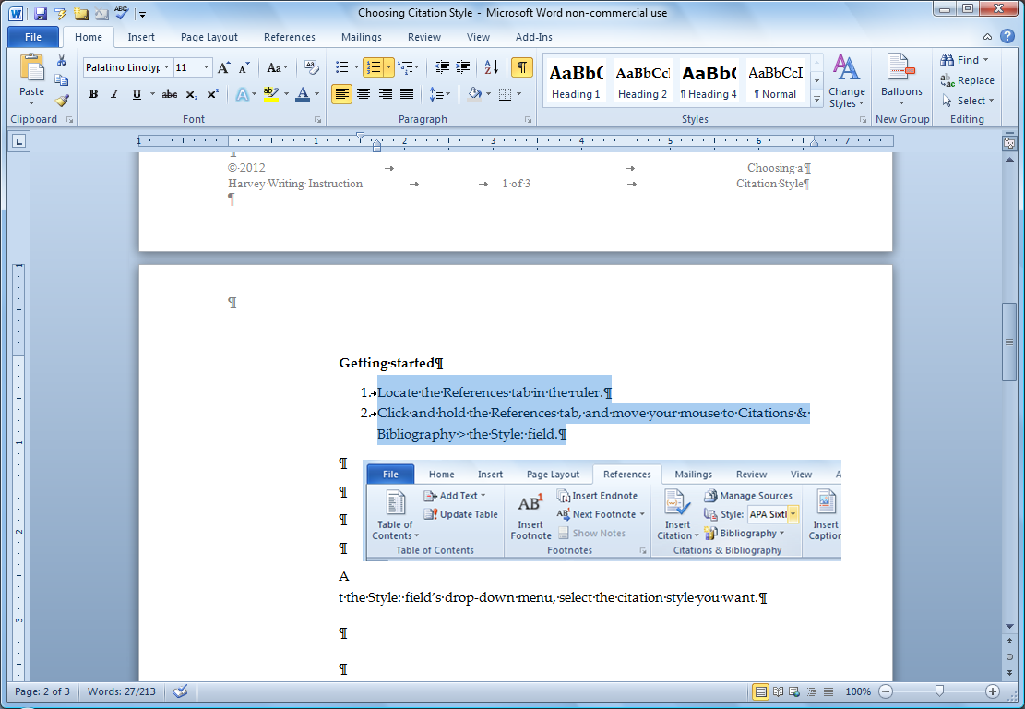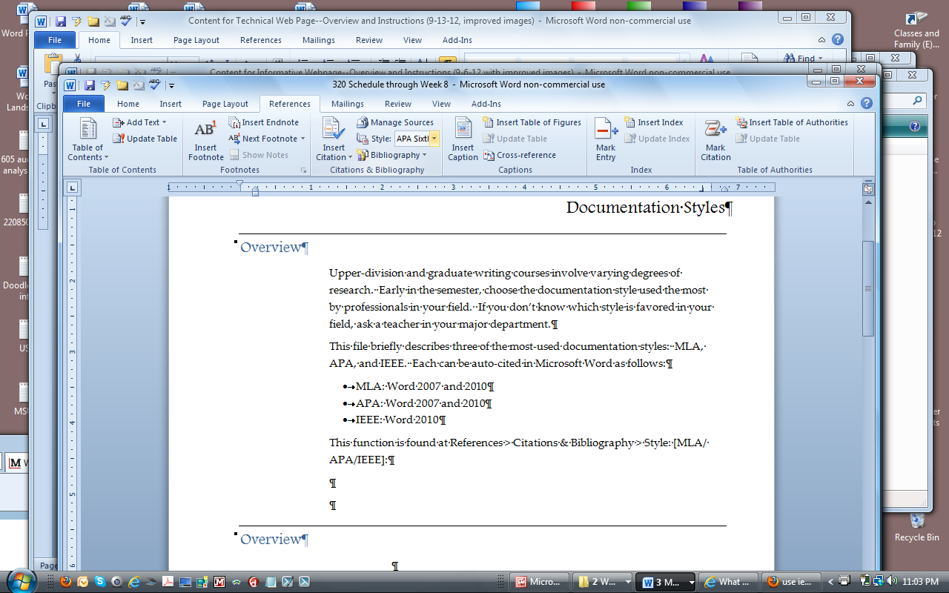

1. Click the References tab and move your cursor to the Citations & Bibliography > the “Style:” field:
2. At the Style: field’s drop-down menu, select the desired citation style. In this example, we’ll use APA style, Sixth Edition. Subsequent screens in the Citations & Bibliography area will be specific to the style you selected, until you choose another.

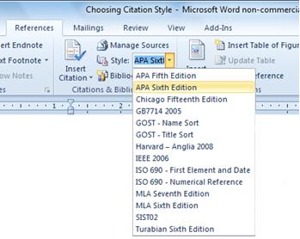

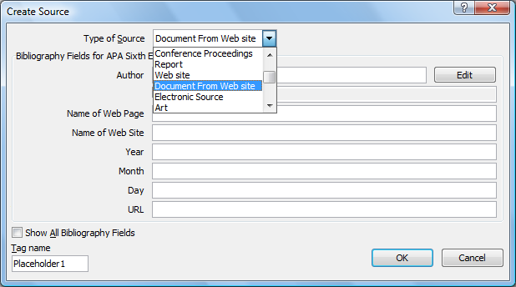

|  |  |  |
| --- | --- | --- |
| IEEE |  | ✓ |

1. Follow the prompts to continue building your citation.

To learn more about the citation feature and its benefits, search online for

“Microsoft Word” citation “video tutorials”

Creating Basic Visuals

# Overview

As you’ve read in our textbook, visuals, or the visual presentation of information, can greatly increase a reader’s ease in understanding new information. Consequently, the ability to create basic visuals is an important workplace skill.

# Tables

Tables put text, numerals, and symbols in a logical arrangement in order to show relationships. You can view video tutorials at Microsoft.com or on third-party video sites (e.g., YouTube.com).

*Microsoft.com*

1. Open the Microsoft Office training page (<http://office.microsoft.com/en-us/support/training-FX101782702.aspx>).
2. Select your version of Word.
3. If you’re using the newest version of Word, click the Word icon:

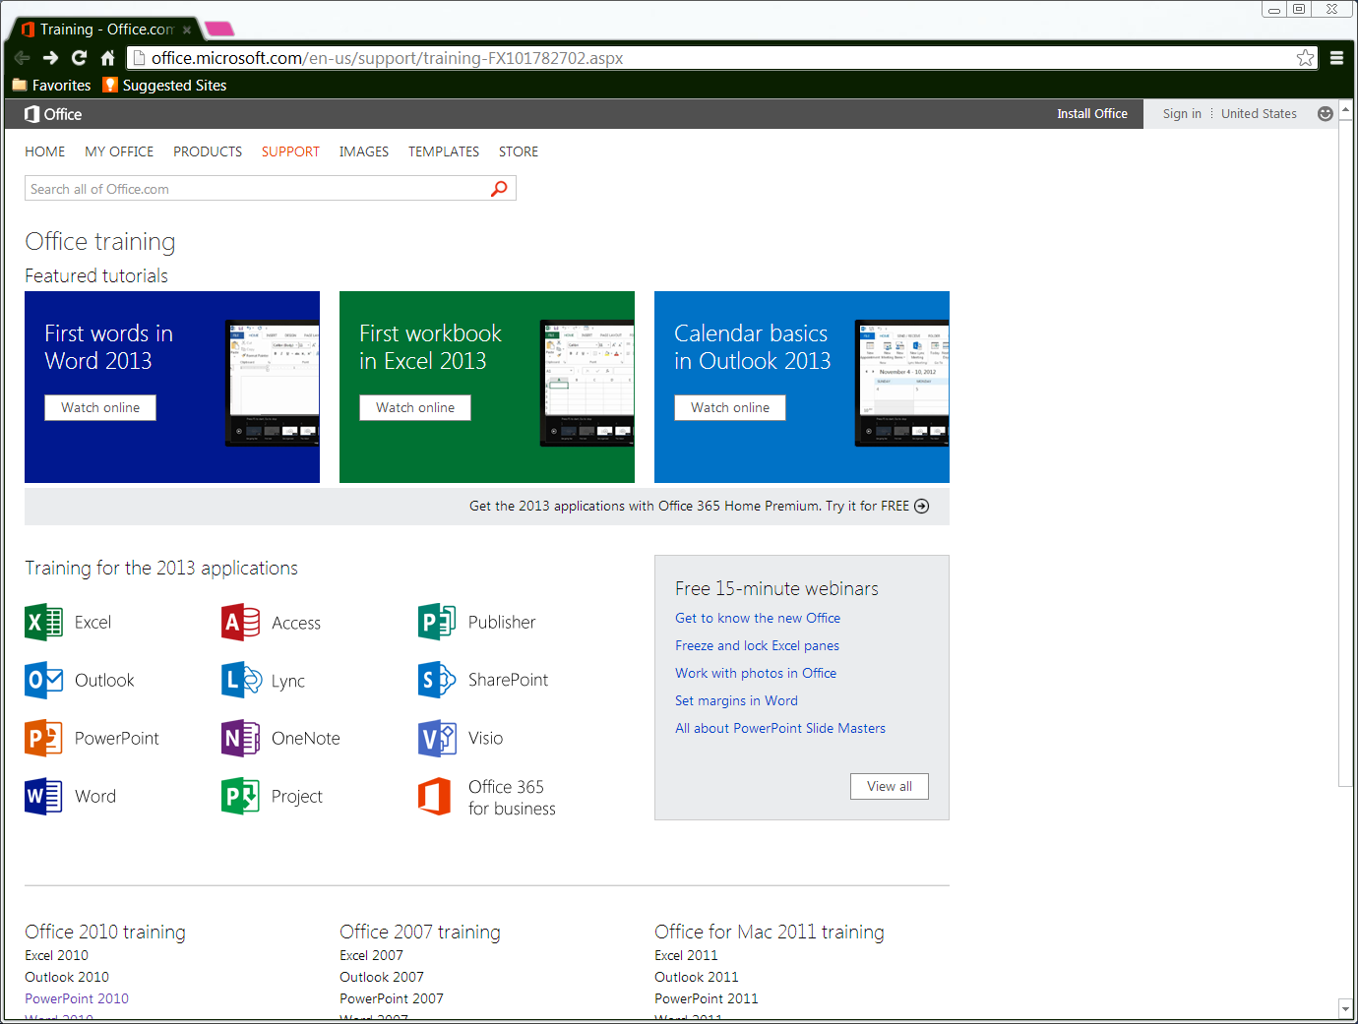

1. If you’re using an older version of Word, scroll to the bottom of the training page and click your version:

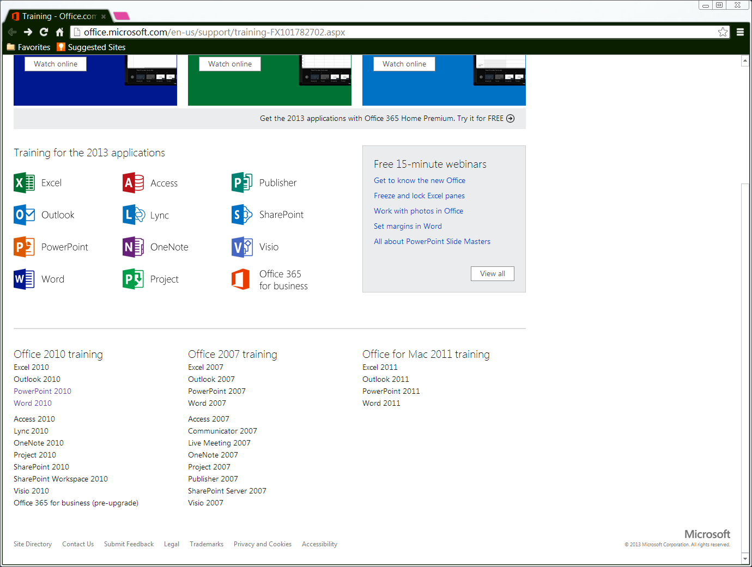

1. Scroll through the training modules listed for your version of Word. If you don’t find what you need, type “tables” into the search field at the top of the page.

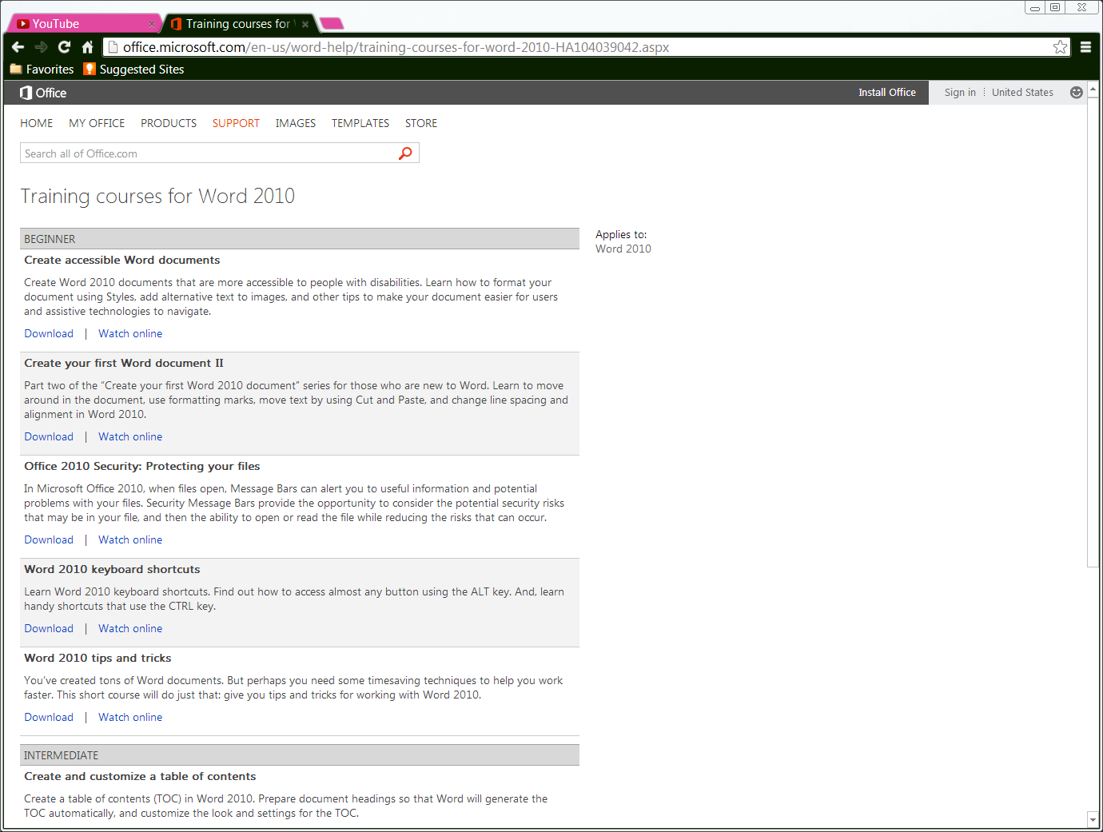

*Third-party video sites (e.g., Youtube.com)*

1. Open the video site (e.g., <http://youtube.com>).
2. Type “Microsoft Word” into the search field, and select the year of your program from the choices that display under the search field.
3. Add the words “tables” and “tutorial” to the search field, and click .

# Flowcharts

A flowchart is a linear illustration that shows how the stages in a process proceed over time.

*Conventions*

* Flowchart shapes contain concise stage names that are written in parallel structure.
* 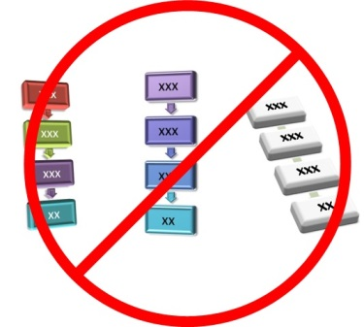One-directional arrows connect the stages to indicate linear progression.
* In a technical document, the simpler the flowchart, the better. Don’t distract your readers from their task by using 3D shapes and multiple colors. Such distractions are common in marketing and advertising, but they can delay your reader’s comprehension.

*Creating a flowchart*

1. Click the place in your Word document where you want the flowchart to appear.
2. Click Insert > SmartArt > Process to display the available types of flowcharts:

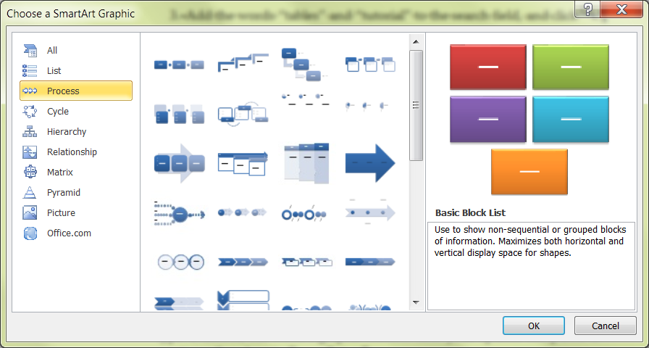

1. Scroll down the window and select the simple vertical chart:

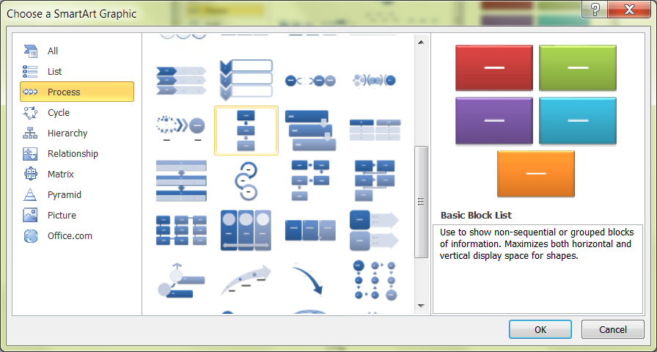

1. Click OK. The flowchart appears in your file and is ready to modify.
2. Click the first text box and type the name of the first stage.
3. Repeat the previous step as needed for the rest of the stages.
4. Add shapes to your flowchart as needed by using the “Create Graphic” area of the tool bar:

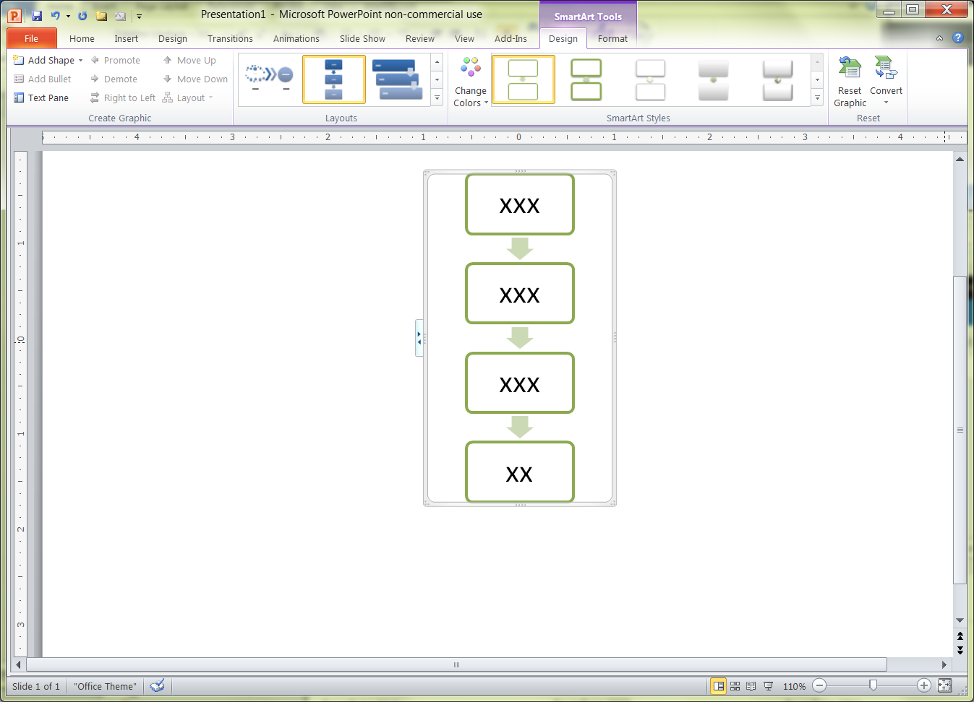

1. Change the arrangement of stages as needed by using the “Layouts” area of the tool bar. For example, if your flowchart becomes too long vertically, you can switch to a horizontal row:



1. Change shape style by clicking the “SmartArt Styles” area:



Reminder: In a technical document, the simpler your flowchart, the better. Don’t distract your readers from their task of learning about the process.

# Site maps (hierarchies)

Site maps are included on websites to show visitors the information available on the website as well as how to navigate between the web pages. Site maps are a type of hierarchy diagram.

*Conventions*

* The shapes in hierarchy diagrams contain nouns or concise noun phrases.
* Plain lines connect the shapes (no arrows).
* 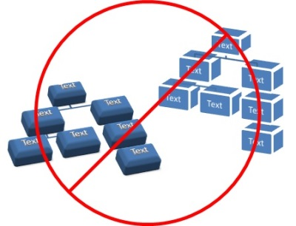In a technical document, the simpler the hierarchy, the better. Don’t distract your readers from their task by using 3D shapes and multiple colors. Such distractions are common in marketing and advertising, but they can delay your reader’s comprehension.

*Creating a site map (hierarchy)*

1. Click the place in your Word document where you want the site map to appear.
2. Click Insert > SmartArt > Hierarchy to display the available types of hierarchy diagrams:

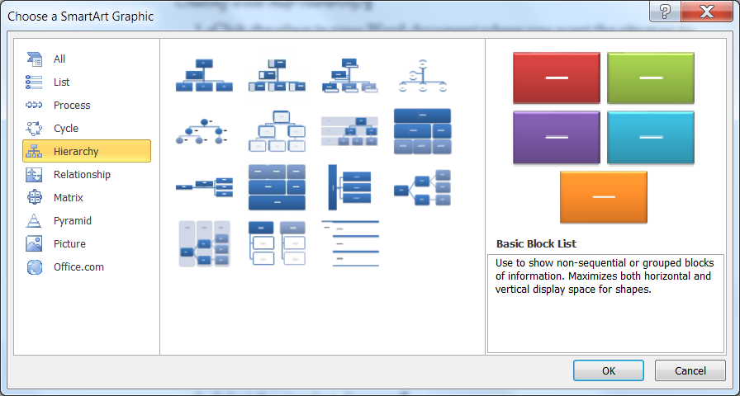

1. Select the simplest hierarchy diagram:



1. Click OK. The site map diagram appears in your file and is ready to modify.
2. To add text, add shapes, and modify your site map’s appearance, refer to step 5 onward in the Creating a flowchart procedure in the previous section.

Using Professional E-mail Style

# Overview

E-mail is everywhere, used by almost everyone.[3] For class purposes, we’ll focus on e-mail in the workplace and professional contexts.

As is the case with all workplace communications, e-mail delivers information that people can perform tasks, make decisions, and continue working.

While not as fast as real-time instant messaging, e-mail has the advantage of being received whether or not the recipient is online when the message is sent. An e-mail message can be printed, forwarded, and saved, and its content can be copied, revised, and repurposed. Because of e-mail’s prevalence and value as a resource, a professional e-mail writing style is highly valued in the workplace.

E-mail is sent for many of reasons, but can be categorized broadly by audience and purpose.

Audience

* + - Internal, those within an organization (e.g., a supervisor)
    - External, those outside of an organization (e.g., a customer)

Purpose

* + - To inform (e.g., a project update)
    - To instruct (e.g., the procedure for purchasing a piece of equipment)
    - To request information (e.g., a project’s start date)
    - To request a decision (e.g., permission to extend a project’s deadline)
    - To request an action (e.g., sending a document)

# Message recipients’ needs and expectations

As is the case with all workplace readers, e-mail recipients are usually busy and have competing obligations. The task of managing e-mail never ends: after the last message has been answered, filed, or deleted, new messages have arrived.

Understanding how message recipients manage their e-mail can help us structure, organize, write messages effectively:

* They check their inboxes only two or three times a day.
* They read only relevant mail and either file or delete the rest. They may prioritize the top 20 percent of new messages and delay action on the remaining 80 percent.
* They only reply when a message asks a question or makes a request.
* They file messages by category, often using an auto-sort function (e.g., new messages with “Project A” in the subject line automatically go into the “Project A” folder).

# E-mail checklist

* Did you limit your message to one project, one topic, and/or one question or related set of questions?
* Did you write a descriptive "Subject" line that moves from general to specific?
* If you’re asking for information, did you refer to your question in the “Subject” line?
* Did you use a greeting (Dear, Hello, [Name] etc.), followed by a colon or a comma?
* Did you start out with one or two sentences explaining why you're writing?
* Did you proofread for the conventions of written English (correct punctuation, capitalization, and spelling)?
* If you're sending an attachment, did you refer to the attachment in the body of your message so your reader knows to look for it?
* Did you use a close (Sincerely, Regards, etc.)?
* Did you end with your name or a signature block?

Using Skype

# Overview

This file is intended to help students who are new to Skype prepare for our videoconferences this semester. It describes how to create a Skype account, add contacts, and make a video call.

Skype.com is easy to navigate, so I encourage you to go directly to <http://www.skype.com/en> and start setting up your account. The sections below provide links to tutorials and document the procedures for creating an account, adding contacts, and making a video call.

# Video tutorials (Windows and Apple users)

Skype maintains a channel on YouTube for video tutorials, for both Windows and Mac users:

* Skype for Windows—How-to Guides: <http://www.youtube.com/playlist?list=PL73F9EA2D155BF3B2>
* Skype for Mac—How-to Guides: <http://www.youtube.com/playlist?list=PLFCAC5DF15DBE2C56>

# Step-by-step procedures (Windows users)

This section documents using Skype for Windows. If you’re using a Mac, refer to the video tutorials instead.

Creating a Skype account

1. Go to www.skype.com/en.
2. Click “Join.”



1. At the “Create an Account” page, fill in the required fields.
   1. Enter your real name in the “First Name” and “Last Name” fields so I’ll recognize you when you send me a contact request, and later when you call. I don’t reply to contact requests or answer calls unless I recognize the person’s name.
   2. Enter both your city and state in the “City” field, so your friends can find you easily.

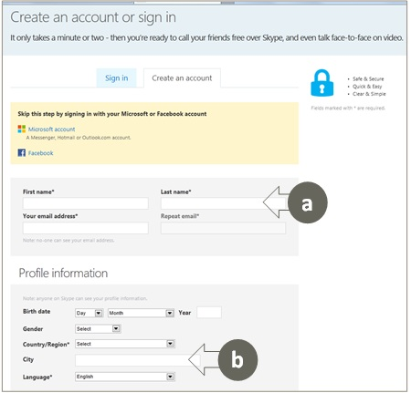

1. Complete the remaining fields, and click “I agree—Continue.”

Adding a contact

1. Log into Skype and enter your credentials. Your Skype page displays.
2. At the upper-left area of the screen, click the "Contacts" tab and select “Add Contact.”

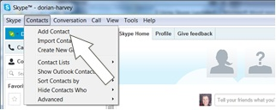

1. Fill in the dialog box fields. As you enter information, the number of matches displays to the right.

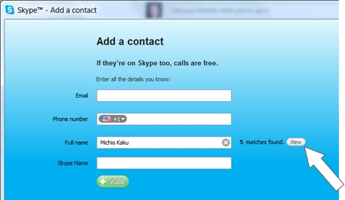

1. Click the "View" button to review the matches found.
2. If your contact is among those listed, click "Add contact." The “Send Contact Request” dialog box opens with the generic text for a contact request.
3. Edit the generic text so your future contact knows who you are, and click "Send request."

NOTE: When you add me as a contact for class, include your name and the course number. I don’t accept contact requests from people I don’t recognize.

1. Repeat steps 2 through 7 to add more contacts.

Making a video call

Students initiate the video calls for our class conferences, just as you would come to my office if we were on campus

1. Log into Skype and enter your credentials. Your Skype page displays.
2. Click on the name of the contact you wish to call. Two options display: “Call with Video” and “Call.”
3. Click “Call with Video.” Your contact can choose whether to answer as a standard call, or to answer with video.
4. Use the icons at the bottom of the image area to adjust settings and share information.
   1. Float your cursor near the bottom of the image area to display the row of icons:

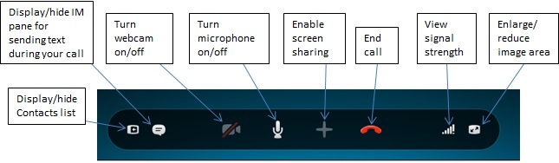

Style and Mechanics Reviews

# Quick links

Finding help with basic grammar and mechanics

Additional help online

1 Agreement

2 Avoiding “There is,” “There are,” and “It is”

3 Active Voice vs. Passive Voice

4 Colons and Semicolons

5 Parallel Structure

6 Misplaced Modifiers

7 Hyphenation

8 Punctuation and Quotation Marks

9 Sentence Combining

10 Third-Person Perspective (Avoiding “You”)

11 Direct Phrasing

# Finding help with basic grammar and

Be sure to make use of your university’s free one-to-one writing help. Each writing center listed below offers one-to-one tutoring and help with assignments, including understanding the instructions, creating a successful first draft, applying my comments, and creating a polished revision. Hours are available at the links below.

* MSUM: The Write Site: <http://web.mnstate.edu/write/index.htm>, 218-477-5937
* NDSU: The Center for Writers: <http://www.ndsu.edu/cfwriters>, 701-231-7927
* UST: The Center for Writing: <http://www.stthomas.edu/writing/services/grad/default.html>, 651 962-4460

# Additional Help Online

* Comprehensive review of grammar and usage: <http://grammar.ccc.commnet.edu/grammar/index2.htm>
* General writing resources page: <http://owl.english.purdue.edu/owl/section/1/>
* Grammar and mechanics: <http://owl.english.purdue.edu/owl/section/1/5/>

1 Agreement

# Subject-Verb Agreement

Subject-verb agreement refers to the fact that a singular subject requires a singular verb form and a plural subject requires a plural verb form. Problems in agreement are very distracting to readers, and tend to occur when elements of a sentence or clause that come between the subject and the verb mislead the writer into thinking that she needs a singular verb form when a plural verb form is required, or vice versa.

Reminders:

1. When two or more singular nouns or pronouns are connected by “or” or “nor,” use a singular verb:

Either the book or the pen is in the drawer.

1. When a compound subject contains both a singular and a plural noun or pronoun joined by “or” or “nor,” the verb should agree with the part of the subject that is nearer the verb:

Either the boy or his friends run every day.

Either his friends or the boy runs every day.

1. Do not be misled by a phrase that comes between the subject and the verb. The verb agrees with the subject, not with a noun or pronoun in the phrase:

One of the boxes is open.

The people who listen to that music are few.

The team captain, as well as his players, is anxious.

The book, including all the chapters in the first section, is boring.

The woman, together with all her dogs, walks down my street.

1. Expressions such as “with,” “together with,” “including,” “accompanied by,” “in addition to,” and “as well” do not change the number of the subject. If the subject is singular, the verb is singular, too:

The President, accompanied by his wife, is traveling to India.

All of the books, including yours, are in that box.

1. The following words and phrases are singular and require a singular verb: each, each one, either, neither, everyone, everybody, anybody, anyone, nobody, somebody, someone, and no one. Examples:

Each of these hot dogs is juicy.

Everybody knows Mr. Jones.

Either is correct.

1. Nouns such as “civics,” “mathematics,” “dollars,” “measles,” and “news” require singular verbs:

The news is on at six.

Note: the word “dollars” is a special case. Referring to an amount of money requires a singular verb, but when referring to the dollars themselves, a plural verb is required:

Five dollars is more than he’s seen in his whole life.

Dollars are often used instead of rubles in Russia.

1. Nouns naming two-part items, such as “scissors,” “tweezers,” and “pants,” require plural verbs.

These scissors are dull.

Those pants are made of wool

1. Collective nouns are nouns that imply more than one person but that are considered singular and take a singular verb, such as “group,” “team,” “committee,” “class,” and “family”:

The team runs during practice.

The committee decides how to proceed.

The family has a long history.

In very few cases, such as the example below, the plural verb is used if the individuals in the group are the focus:

My family have a history of never being able to agree.

# Noun-Pronoun Agreement

Similar to subject-verb agreement, noun-pronoun agreement refers to the fact that a singular noun requires a singular pronoun and a plural noun requires a plural pronoun. Again, problems occur when elements of a sentence or clause that come between the noun and the pronoun mislead the writer into thinking that he needs a singular pronoun when a plural pronoun is required, or vice versa.

Whenever possible, use a plural noun, such as “employees” or “users,” and then use "they" as the pronoun. If you do use a singular noun but feel that “he or she” is awkward, it’s acceptable to alternate between "he" and "she."

Examples:

* Everyone knows that they’ll have indigestion after eating a chocolate-broccoli muffin.
* Everyone knows that she’ll have indigestion after eating a chocolate-broccoli muffin.
* People know that they’ll have indigestion after eating a chocolate-broccoli muffin.
* The troupe of knife jugglers shocked their audience when a butcher knife accidentally cut off the tail of an old woman's poodle.
* The troupe of knife jugglers shocked its audience when a butcher knife accidentally cut off the tail of an old woman's poodle.
* If everyone picked up a single piece of litter every day, they would discover that the planet would be a much cleaner place.
* If everyone picked up a single piece of litter every day, he or she would discover that the planet would be a much cleaner place.
* If people picked up a single piece of litter every day, they would discover that the planet would be a much cleaner place.
* That member of the track team always wins races because they have no fear of leaving some skin on the pavement.
* That member of the track team always wins races because he has no fear of leaving some skin on the pavement

*Source: Purdue University © 2004*

2 Avoiding “There is/are” and “It is”

# Extra words delay the reader

Good writing is concise, which means that it uses the fewest words possible to convey an idea completely. Starting a sentence with “There is/are . . .” or “It is . . .” adds an extra subject and verb to a sentence before getting to the main idea.

We use “There is/are . . .” and “It is . . .” often in spoken English. But writing is by definition a more conscious act in which we can think a bit longer about how we express an idea.

Removing these “false starts” reduces the number of words that have to be read before a reader can find the desired information.

# Examples

The examples below show that removing “there is/are” and “it is” from the start of a sentence creates a direct style that conveys information efficiently.

* There are six weeks of class left.
  + - * Six weeks of class remain.
* There were fewer students enrolled in the online section than in the classroom section.
  + - * Fewer students enrolled in the online section than in the classroom section.
* There were four graded projects required in the course.
  + - * The course required four graded projects.
* There was evidence of contamination in the soil sample.
  + - * The soil sample showed evidence of contamination.
* It is important to follow safety guidelines throughout the procedure.
  + - * Follow safety guidelines throughout the procedure.
* It is necessary to place the chemical tray under the beaker.
  + - * Be sure to place the chemical tray under the beaker.
* In older elevators, it is when the elevator car is rising that the greatest tension is on the cable.
  + - * In older elevators, the cable undergoes the greatest tension when the elevator car is rising.

3 Active and Passive Voice

# Definitions

Most of us first hear “voice” applied to writing when we’re in a literature or a writing class. In that context, “voice” is the writer’s distinctive style or manner of expression.

In a grammatical context, the term “voice” applies to a sentence’s active or passive structure.

Active voice

A sentence is in “active voice” when the subject acts (or has acted, or will act, etc.) on the object of the verb:

• The cat ate the mouse.

• Jordan will analyze the compound.

• The research team might visit the site.

In almost all situations, active voice is preferred to passive voice, because active voice is direct and concise.

Passive voice

A sentence is in “passive voice” when the object that receives (or has received, or will receive, etc.) the action is the grammatical subject of the sentence.

As shown below, passive construction often includes a form of the verb “to be” before the action verb, and may include the preposition “by”:

• The mouse was eaten.

• The mouse was eaten by the cat.

• The compound will be analyzed.

• The compound will be analyzed by Brook.

• The factory might be visited.

• The factory might be visited by the research team.

# Passive Voice and Process Documentation

In a process, something occurs, bringing about a result. Glacial movement is a process; cell division is a process.

Passive voice focuses the reader’s attention on the object of the action, and puts the agent (performer of the action) in the background. For this reason, passive voice is often preferred when documenting a process, in which what happens is more important than what causes it to happen.

Notice in the examples below that identifying who or what does the action would distract the reader from the process being described:

• The sides of the filter are roughened to prevent water from streaming between the walls and the sand. (It doesn’t matter what or who does the roughening.)

• The filter beds are washed to free them of accumulated particles. (It doesn’t matter what or who does the washing.)

• Operating temperatures are checked daily to ensure the motor is not damaged. (It doesn’t matter who does the checking, only that the checking occurs.)

• The trench was designed to conform to the limits of the heat zone. (It doesn’t matter who did the designing, only that the design conforms.)

4 Colons and Semicolons

# “Higher-Order” Punctuation

Semicolons and colons can be viewed as “higher-order” punctuation. They are virtually logical symbols, and are helpful tools in writing concisely.

When readers see a semicolon or a colon approaching, they are tipped off that a logical relationship exists between the two ideas they’re encountering. This tipping-off simplifies the audience’s task of absorbing the information as they encounter it.

Colons and semicolons are used in the presence of independent clauses. An independent clause is a group of words that has a subject and verb and could stand independently as a complete sentence.

# Colons

When to use a colon

Colons are used in two ways:

* After an independent clause to announce (1) a single word, (2) a phrase, or (3) a list:

(1) Only one thing kept her awake in class: hunger.

(2) Only one thing kept her awake in class: the other students’ intermittent laughter.

(3) For the first assignment, you’ll write one of three types of reports: an inspection report, a laboratory report, or a progress report.

* Between two independent clauses when the first makes a claim and the second supports the claim:
* Trust is like love: It cannot be coerced.
* Her master’s degree paid off: Her salary has doubled.

How to use a colon

* As with the items in any series, this ideas listed after a colon must be written in parallel structure (all noun phrases, all verb phrases, etc). The two lists above show parallel structure.
* Don’t use a colon to separate a verb from its object(s):
* The toxins noted were: tabun, sarin, formaldehyde, polyethylene, and benzine.
  + - * A number of toxins were noted: tabun, sarin, formaldehyde, polyethylene, and benzine.
* Don’t use a colon to separate a preposition from its object(s):
* The areas to be painted consisted of: the three gable ends, all of the trim work, and the front and back porches.
  + - * Several areas were to be painted: the three gable ends, all of the trim work, and the front and back porches.

# Semicolons

Semicolons also join independent clauses.

Required uses

A semicolon is needed when the second independent clausebegins with or includes “however,” “therefore,” or “consequently”:

* Your bike is fast; however, my bike is faster.

Your bike is fast; mine, however, is faster.

* My bike is faster than yours; therefore, I’ll win the race.

My bike is faster than yours; I, therefore, will win the race.

* I’ll win the race; consequently, you’ll owe me $500.

I’ll win the race; you, consequently, will owe me $500.

Semicolons are needed to separate the items in a series when one or more of the items includes a comma:

* Three alumni tied for having traveled the farthest to attend the reunion: Julie and Mike Smith, Bangor, ME; Mary and Jim Johnson, Honolulu, HA; and Debbie and Gary Bakke, Singapore.
* Employment histories fell into three categories: low achievers, who earned fewer than 50 points; mid-range achievers, who earned between 50 and 100 points; and high achievers, who earned more than 100 points.

Other uses

A semicolon can sometimes replace the conjunctions “and,” “ but,” or “or”:

* I came; I saw; I conquered.
* My hands were chapped and raw; his were soft and warm.
* We can do this the easy way; we can do this the hard way.

A semicolon can sometimes replace “because”:

* My sister couldn't type; she had sprained her wrist in gym.
* I can’t go out tonight; I have a test tomorrow.

5 Parallel Structure

# Parallel structure and technical communication

Parallel structure is a writing strategy that applies consistent grammatical form to sentence elements that are alike in function.

Parallel structure is a highly efficient way to deliver oral and written information, and thus is an essential strategy in technical communication.

# Creating parallel structure

Simple series with coordinating conjunctions

After writing ideas in identical grammatical forms (e.g., noun phrases, adverbs, verb phrases), the most basic way to create parallel structure is to join them with a coordinating conjunction, such as "and" or "or."

Series of noun phrases:

The dictionary can be used for to find word meanings, pronunciations, correct spellings, and irregular verbs.

Series of adverbs:

The production manager was asked to write his report quickly, accurately, and thoroughly.

Series of verb phrases:

My sister does poorly in school because she turns her assignments in late and waits until the last minute to study for tests.

Parallel clauses

A parallel structure that begins with clauses must continue with clauses. Changing to another pattern will break the parallelism. Note that changing the voice of the verb between active and passive also breaks the parallelism.

* The coach told the players that they should get a lot of sleep, that they should not eat too much, and to do warm-up exercises before the game.
* The coach told the players that they should get a lot of sleep, that they should not eat too much, and that they should warm-up before the game.
* The coach told the players to get a lot of sleep, to not eat too much, and to do warm-up exercises before the game.
* The salesman expected that he would present his product at the meeting, that there would be time for him to show his slide presentation, and that questions would be asked by prospective buyers [note switch to passive voice].
* The salesman expected that he would present his product at the meeting, that there would be time for him to show his slide presentation, and that prospective buyers would ask questions.

Not only . . . but also . . . .

Use the “not only…but also” structure carefully. It is highly useful, but is easy to lose track of as the sentence moves along.

* Following these suggestions will not only increase patient well being, but employee satisfaction as well.
* Following these suggestions will not only increase patient well being, but also boost employee satisfaction.
* She wanted not only to buy a car, but also a house.
* She wanted to buy not only a house, but also a car.

# Using vertical lists

Lists speed understanding

The two passages below contain the identical information. Which is easier to read?

The coach advised her players that they should get seven hours of sleep, that they should avoid eating too much, and that they should warm up before the game.

~~~~~~~~~~~~~~~~~~~~~~~~~~~~~~~~~~~~~~~~~~~~~~~~~~~~~~~~~~~~~~~

The coach gave her players some advice:

* To get seven hours of sleep
* To avoid eating too much
* To warm up before the game

The second passage is easier to read, because its list format 1) prepares us for three items of similar function and importance, and 2) removes unnecessarily repeated words.

Bullets or numbers?

A bulleted list prepares the reader for ideas that are all of the same importance and are not to be considered in any type of order. The three bulleted items above, for example, are of equal value to the passage and could have been presented in any order.

NOTE: Bulleted lists may be arranged in a descending order of importance, such as most dangerous toxin first, largest of several budgets first., etc.

A numbered, or ranked, list (includes alpha characters [a., b., c.]) is required in the following situations:

* + - * The list presents steps in a procedure or stages in a process.
      * The list tracks a list elsewhere in the document.
      * Elements in the list are cross-referred elsewhere in the document. Numbering in this instance avoids vague and inefficient references such as, “the third bullet in the second section on page 4.”

# Proofreading for parallel structure

Proofread your documents for the opportunity to use parallel structure, and proofread your parallel structures for balance:

* + - * Skim your writing, pausing at the words “and” and “or.” Check on both sides of these words to see whether the joined items joined are parallel.
      * When you encounter phrases in a series, visualize them in a vertical list to see if they are parallel.
      * Listen to the sound of the items in a series or the items being compared. Do you hear the same rhythm for each? If something interferes with the rhythm, check to see whether the passage’s structure needs revision to become parallel.

6 Misplaced Modifiers

# Modifiers and technical writing

When people read a document for information, they depend on word placement for meaning. The less a reader knows about the subject, the greater the dependency on word placement.

Modifiers are words or phrases that add information to a sentence’s core parts of speech. Examples include adjectives and adjectival phrases, which modify nouns, and adverbs and adverbial phrases, which modify verbs.

The following sentence starts out as only core elements, and gains a modifier with each repetition:

The cat sleeps.

The white cat sleeps.

The white cat sleeps curled up.

The white cat sleeps curled up by the fireplace.

The underlined words modify, or enhance the meanings of, “cat” and “sleep.” In this case, we’re completely familiar with cats, sleeping, the color white, and what it means to be curled up.

In a poorly written sentence, a modifier’s intended element can be too far away or missing entirely, causing the modifier to be incorrectly associated with the nearest words. In the best case, the reader laughs at the silly result; in the worst case, the reader suffers a serious consequence.

Remember: In technical writing, one person’s error is the next person’s data.

# Examples

* Barking and leaping, I watched Bingo race around the fence. (Problem: I didn’t “bark and leap.”)
* Barking and leaping, Bingo raced around the fence.
* Changing the oil every 3,000 miles, the car seemed to run better. (Problem: The car didn’t “change the oil.”)
* Changing the oil every 3,000 miles, I found the car had much better gas mileage.
* Having eaten lunch, the table was cleared. (Problem: The table didn’t “eat lunch.” These two ideas are so unrelated that two sentences are needed.)
* Having eaten lunch, the people left. Afterwards, the staff cleared the table.
* With a glance in my rear-view mirror, the car drove ahead. (Problem: The car didn’t “glance in my rear-view mirror.”)
* With a glance in my rear-view mirror, I drove ahead. Or . . .
* With a glance in my rear-view mirror, I saw the other car drive ahead.
* Hoping to keep the young recruits in shape, a summer exercise program was set up. (Problem: The summer exercise program didn’t “hope.”)
* Hoping to keep the young recruits in shape, the coaching staff set up a summer exercise program.

7 Hyphenation

# Hyphenation and technical writing

“Take hyphens seriously and you will surely go mad.” Author unknown

Hyphenation can help communicate information clearly to readers. The less readers know about a topic, the greater the number of words that will be unfamiliar, and the more important it becomes to make sure that the relationships among words are completely clear.

When the words aren’t new to a writer, the need for hyphenation may not be obvious. But the reader, who may be just learning about the topic, needs to know whether the first word relates to the next word or to the word after that.

Remember that many levels of misunderstanding are possible when writing isn’t clear, from the simply annoying to the life-threatening.

# Common uses

• Dividing a word into syllables, as at the end of a line. The rules for where to break a word at the end of a line are complex and not easily memorized. Word-processing programs apply the rules for us, but when we’re away from a computer, it’s best to check the dictionary.

• Writing out numbers: Hyphens are used in writing out fractions (five-eighths, one-fourth) and the compound numbers twenty-one through ninety-nine.

• Adding certain prefixes to words: Again, the rules vary, so it’s best to consult a dictionary.

# Compound modifiers

Hyphens are used to join two or more words that serve as a single adjective (modifier) before a noun:

* one-way street
* chocolate-covered peanuts
* well-known author
* four-year-old boy

However, compound modifiers that come after a noun are not hyphenated:

* Our street is one way.
* The peanuts were chocolate covered.
* The author is well known.
* My son is four years old.

# Noun stacks

When one goal of writing is to be concise, noun stacks can occur. A noun stack is a series of nouns used as adjectives before the noun being modified, as shown in this example:

Proper integrated circuit packaging type identification and applications are crucial to electrical system design and repair.

To keep all the words in the same order as above, you would need hyphens:

Proper integrated-circuit packaging-type identification and applications are crucial to electrical-system design and repair.

A better solution is to rewrite the sentence:

Identifying the proper type of packaging for integrated circuits is crucial to the design and repair of electrical systems.

# Suspended compounds

With a series of nearly identical compounds, we sometimes delay the final term (usually a noun) until the last instance of the compound:

• The third- and fourth-level diplomats weren’t invited.

• Both full- and part-time employees will get raises this year.

• We don't see many three-, four-, or five-year-old children out alone.

Use this approach sparingly in technical writing, because it delays the reader’s understanding of exactly what is being discussed. In some cases, this delay can cause a reader to go back and re-read the series in order to make sense of it.

8 Punctuation and Quotation Marks

# Basic guidelines

American English

The conventions of American English place commas and periods inside the quotation marks:

• “Design,” by Robert Frost, is my favorite poem.

• My favorite poem is Robert Frost's "Design."

All other punctuation appears outside of quotation marks, unless it’s part of the quoted material:

• Frost emphasizes a single truth in his poem "The Road Not Taken": Our choices dictate our paths through life.

• What is the meaning of the term “half-truth”?

• Pilate asked, “What is truth?”

British English

In Canada and the United Kingdom, rules require that only the word or phrase that is quoted appears inside the quotation marks:

• My favorite poem is Robert Frost's "Design".

Beyond that, the rules are the same as for American English:

• What do you think of Robert Frost's "Design"?

• I like Robert Frost’s "Design"; my favorite poem, however, is Emily Dickinson’s “The heart asks pleasure first”.

# Quoting sources

When working a writer’s or speaker’s words into a sentence, use a variation of the verb “to say” (e.g., “to observe,” “to note,” “to explain,” “to conclude,” etc.):

• Dr. Phillip Savage, Chair of Chemical Engineering at the University of Michigan, said, "*Chemical Industry Today* is recognized internationally as one of the leading journals in its field."

If a quoted word or phrase fits into the flow of the sentence without a break or pause, a comma isn’t necessary:

• The Secretary of Agriculture’s statement that “We need to properly guard against intentional as well as unintentional threats to the nation's food supply” struck a chord with the seminar attendees.

# The word “[word]”

Use quotation marks to set a word or phrase apart from the rest of a sentence so that it can be considered outside of its context.

Examples:

* The word “get” has too many definitions to be of use in a technical document.
* The term “synecdoche” was new, and frightening.

# “Rah-rah” quotation marks

Don’t use quotation marks to emphasize a word. These are called “rah-rah” quotation marks and, unfortunately, we see them everywhere:

Big "Sale" Today!

The “McNaughtons”

Quotation marks used this way signal that you’re using the word in a peculiar way, and that you actually mean something else.

9 Sentence Combining

# Sentence combining in technical writing

Sentence combining involves putting together two or more short, related sentences in a way that 1) more clearly shows the relationship of ideas, and 2) removes unnecessary repetition. When ideas are in a logical relationship to each other, and when unnecessary words are eliminated, readers can move more quickly through a passage and comprehend the information more efficiently.

While the goal of sentence combining is to speed readers’ understanding of the relationships among ideas, the immediate effect is to remove the choppiness caused by using two or more short sentences in a row.

# Using relative clauses

The following groups of sentences can be combined by changing the secondary sentences into relative clauses (clauses signaled by words such as WHO, WHOM, WHICH, THAT, and WHOSE).

Example 1

Our CFO hosted this year’s Fourth of July picnic.

Our CFO began her long career in our company’s mailroom.

**🗸**Our CFO, who began her long career in our company’s mailroom, hosted this year’s Fourth of July picnic.

Example 2

The laboratory’s fume hood isn’t working.

The lab staff’s safety depends on the correct operation of the fume hood.

The lab staff refuses to be in the lab during experiments.

**🗸**The lab staff, whose safety depends on the correct operation of the fume hood, refuses to be in the lab during experiments.

# Using participial phrases

The following pair of sentences can be combined by changing the secondary sentences into participial phrases (phrases marked by words ending in “-ing” or “-ed”).

Example

He stood at the photocopier after his long lunch.

His eyes were glazed and his shoulders were slumped.

**🗸**He stood at the photocopier after his long lunch, eyes glazed and shoulders slumped.

# Using appositives

The following pairs of sentences can be combined by reducing the secondary sentences to appositives (phrases which explain or rename a noun).

Example 1

The manager walked down the aisle past the supervisor’s and director’s heated argument.

The manager is an accomplished scheduler.

**🗸**The manager, an accomplished scheduler, walked down the aisle past the supervisor’s and director’s heated argument.

Example 2

The company’s product line features many brands and models.

The product line is state-of-the-art, implantable biomedical devices.

**🗸**The company’s product line, state-of-the-art, implantable biomedical devices, features many brands and models.

# Using prepositional phrases

Prepositions are words that signal a modification to the word or phrase before it (e.g., “She graduated with honors,” and “He’s a medical device engineer in Minnesota”). Common prepositions are TO, IN, WITH, BY, FROM, UNDER, AFTER, ASIDE, BEFORE, and WITHOUT.

The following groups of sentences can be combined by reducing the less important sentences to prepositional phrases.

Example 1

Every morning, the factory line leader reviews employee arrival times.

The factory line leader uses an iPad to view the data.

She reviews arrival times at exactly 7:55 a.m.

**🗸**Every morning at exactly 7:55, the factory line leader reviews employee arrival times on her iPad.

Example 2

A new football stadium is being built.

The stadium is at the intersection of I-35W and County Hwy. 96.

It is located between a nature preserve and a community college.

**🗸**The stadium is being built at the intersection of I-35W and County Hwy. 96, between a nature preserve and a community college.

# Using conditionals

Conditionals are words that signal a subordinate relationship to the sentence’s main idea (e.g., “You’ll earn a good grade if you work hard,” and “Unless you work hard, you won’t earn a good grade”). Common conditionals are IF, BECAUSE, WHEN, WHILE, WHERE, SO, UNLESS, and EVEN THOUGH.

By using conditional words, the following pairs of sentences can be combined in a way that makes one sentence subordinate to the other.

Example 1

The pilot had to fly at higher-than-normal speed to arrive at the destination on time.

The airliner’s departure had been delayed by an hour.

**🗸**The airliner’s departure had been delayed by an hour, so the pilot had to fly at higher-than-normal speed to arrive at the destination on time. Or . . .

**🗸**The pilot had to fly at higher-than-normal speed to arrive at the destination on time, because the airliner’s departure had been delayed by an hour.

Notice that in both of the combined versions above, the dominant idea is that because of the condition under which the pilot was flying, he had to fly at a higher-than-normal speed.

Example 2

Profits were higher this year than last year.

Upper management is unsatisfied with this year’s figures.

**🗸**Upper management is unsatisfied with this year’s figures, even though this year’s profits were higher than last year’s.

Example 3

The motor plant is in danger of being closed.

The plant won’t be closed if employees can bring the new product to market by April 30.

**🗸**The motor plant is in danger of being closed unless employees can bring the new product to market by April 30.

10 Third-Person Perspective (Avoiding “You”)

# “Perspective” in technical writing

To understand the value of third person perspective in technical writing, we can start by understanding what “person”—specifically, “first person,” “second person,” and “third person”—means.

First person

First-person perspective uses the personal pronouns “I,” “me,” “my,” and “mine.” An example of first person perspective is, "I am writing this report to explain that . . . ."

Using first person perspective in this way is informal, and unacceptable in workplace reports and similar documents. First person is acceptable, however, in correspondence, such as letters and e-mail.

Second person

Second-person, or “you,” perspective uses the pronouns “you,” “your,” and “yours.” An example of second person or “you” perspective is, "You can see in the following observations that . . . ."

Using second-person, or “you,” perspective is considered incorrect in technical writing because it addresses the reader and moves attention away from the topic or subject of the document.

Note that again, second person is acceptable in correspondence, such as letters and e-mail.

Third person

Third-person perspective uses the pronouns “he,” “she,” “it,” “one,” and “they.” An example of third-person perspective is, “The technician applies the coating to the surface, and then . . . ."

Using third-person perspective achieves several elements that are essential to documents written in the workplace:

* It keeps your reader’s attention on the topic being discussed or documented.
* It keeps the tone of your writing objective and factual.
* It prevents a conversational, wordy tone from creeping into your writing.

# Examples

The following examples show instances of a workplace-related statement or passage written with second-person (“you”) perspective, when third-person perspective is required.

Example 1

* In this report, you will see that factory personnel are adhering to our production schedule.
  + - * Readers of this report will see that factory personnel are adhering to our production schedule. Or . . .
      * This report documents the efforts of factory personnel to adhere to our production schedule.

Example 2

* First, you align the insert’s center rod with the block’s ½ in. receptacle.

**🗸**Step 1. Align the insert’s center rod with the block’s ½ in. receptacle.

Example 2

* The classroom was so crowded that you couldn’t find a desk.
  + - * The classroom was so crowded that students couldn’t find a desk.

11 Direct Phrasing

# Direct phrasing in technical writing

Direct phrasing is a sentence-level quality that allows a reader to quickly grasp the information being presented in the sentence. Direct phrasing is objective and unambiguous, and therefore easy to understand.

Circular, indirect, and convoluted (wandering) phrasing can be the result of starting a sentence by expressing an idea one way, and continuing the sentence by expressing the idea in a different way.

# Examples of circular, indirect, and confusing phrasing

The sample sentences below all actually occurred. They are from student reports for this class or statements published in the media. In all cases, the confusing phrasing is the result of starting the sentence with one structure and finishing it with another.

NOTE: The statements found in the media are from people who were quoted as they spoke publicly without scripts. Unscripted public speaking doesn’t offer the speaker a chance to rewrite or think further about the organization of a statement, so it can occasionally be indirect and unclear when analyzed later.

Published Examples

* That is where obviously a lot of investment money is going to go there at a time when the United States has $120-a-barrel oil prices.
* That is where a lot of investment money is going to go, and at a time when the United States has $120-a-barrel oil prices.
* Everyone was evacuated safely except for one individual suffered a minor injury.

Everyone was evacuated safely, and only one person suffered a minor injury.

That's the major focus for the President right now is expanding our trade opportunities and to look for ways to open markets for America's farmers and ranchers and businesses and service providers.

The President’s major focus right now is to expand our trade opportunities by looking for ways to open markets for America’s farmers and ranchers, businesses, and service providers.

* That is the role of the Fed, is to take that kind of action.
* The role of the Fed is to take that kind of action.

Student Examples

* Step 3. According to the deadlines of each Task List (Daily, Weekly, Monthly and Yearly) and the priority of tasks within each list, log each task into the schedule of the planning aid. (Note how far you must read before discovering the action of this step.)
* Step 3. Log each task into the schedule of the planning aid according to the deadlines of each Task List (Daily, Weekly, Monthly and Yearly) and the priority of tasks within each list.
* To vortex [not a verb] the contents in a tube it just needs to be placed on the top part of this machine.
* The contents are centrifuged in a tube, which is placed on the top part of this machine.
* By following this schedule it will save time as well as keeping the business running efficiently.
* Following this schedule will save time and keep the business running efficiently.
* In order to start a project like this is going to take cooperation and communication from all of the staff.
* Starting a project like this will take cooperation and communication from all of the staff.
* My goal is right around the 4th of July holiday is what I'm targeting.
* My goal is [to be finished] right around the 4th of July holiday.
* Depending on how soon I graduate will decide my future plans.
* My future plans depend on how soon I graduate.

12 “That” and “Which”

# “That” and “which” in technical writing

When a technical writer is choosing between “that” and “which,” it is usually at the start of a modifying phrase. The modifying phrase can be providing more information about a noun (or noun phrase) or a verb (or verb phrase).

# Guidelines

General

When choosing between “that” and “, which” to start a modifying phrase, the idea being modified precedes the modifying phrase.

The nature of what is being modified guides whether “that” or “, which” is the correct choice. The examples in the next section clarify this guideline.

Comma use

A “, which” phrase is clarified by using a comma before it. A “, which” phrase can appear some distance from the idea it modifies, so a comma is often required for clarity.

A “that” phrase should not have comma before it. The “that” phrase modifies what comes immediately before it, and the two should not be separated.

How it “sounds”

Many sources state that a writer should “go by how it sounds.” This approach can work for writers who have internalized the correct use of “that” and “which” from reading extensively, or who can easily apply writing styles they have read to the documents they need to write.

A problem with this guideline is that “how it sounds” requires a relaxed frame of mind. The minute we stop to examine a sentence we’re writing, we switch from being relaxed to being analytic, and “how it sounds” becomes difficult to assess.

# Examples

“The author gives several examples, which shows his extensive experience.”

* The “, which” phrase modifies the author’s action of giving the examples.
* Notice that the comma clarifies the sentence’s meaning by unifying the idea being modified before the modifying phrase starts.

“The author gives several examples that show the extent of his experience.”

* The “that” phrase modifies the examples.
* Notice the absence of a comma. Even if the idea being modified were to involve many more words, a comma still wouldn’t be needed:

“The author gave several examples from his childhood in a yurt on the steppes of western Siberia that show the extent of his experience.”

# Safety net

When in doubt, rewrite the sentence to avoid the need for either word:

“The author’s use of examples in Ch. 4 shows his extensive experience.”

“The author’s examples in Ch. 4 show his extensive experience.”

Appendix: Instructor’s Information

# Professional background

I earned my undergraduate English degree at Minnesota State University Moorhead, and my graduate English degree at North Dakota State University in Fargo. While at NDSU, I taught freshman composition and business writing.

In 1984, I moved to the Twin Cities, where I was a writer at Honeywell for 10 years, first as a technical writer and then as a promotional writer. I earned an M.B.A. in marketing from University of St. Thomas, St. Paul, during that time, and became a technical writer and communications consultant in 1994.

My clients represented a number of industries, including biomedical devices, energy management, human resources development, and K-12 education. I wrote website content, scientific and sociological white papers, internal employee communications, direct e-mail sales campaigns, clinical case studies, media/press kits, trade magazine articles, and scripts for DVD and audio publications.

I also wrote curricula for middle school and high school life skills courses, on topics including nicotine addiction, shaken baby syndrome, fetal alcohol exposure, and fetal drug exposure.

# Philosophy of teaching

All people deserve to be able to communicate effectively in writing. To do so, however, they need the following circumstances, which I build into all of my writing courses:

• Motivation to write effectively  
• Understanding of the audience's needs and expectations  
• Practice, practice, practice

I find that the most enjoyable part of teaching is connecting with students, which we accomplish in video conferences for my online courses. It's gratifying to see how students' writing improves by the end of the semester, and to know that students are prepared to write in their professions as a result of taking one of my classes.

My goal is to share my interest, experience, and insights about writing in one’s profession so that students receive practical value for their tuition investment.

# Curriculum vita

**Education**

M.B.A., concentration in Marketing, 1994; University of Saint Thomas, St. Paul, MN

M.A. in English, concentration in medieval literature, 1982; North Dakota State University, Fargo

B.A. in English and Philosophy, 1978; Minnesota State University Moorhead

**Writing Instruction**

Web-Based Instruction—January 2006 to present

**Minnesota State University Moorhead—English Dept.**

*Sept. 2009 to present*

• Engl. 387, Technical Report Writing (4 cr.): Process-oriented writing course in which students practice analyzing audience needs and expectations, using conventional formats appropriate for the audience and the context, determining when graphic elements are necessary and incorporating them effectively into documents, and following standards used by technical professionals. Assignments are individualized for students' degree programs, and include progress reports, inspection reports, technical procedures, and feasibility reports. *Taught Spring, Summer, and Fall 2010 and 2011.*

• Engl. 487, Advanced Technical Report Writing (4 cr.): Process-oriented writing course that emphasizes theoretical aspects of audience analysis, principles of document organization and design, and technical writing style. Students learn to design effective documents and visuals, to find and use authoritative sources in their fields, and to use various research techniques. Students also engage in a collaborative translation project with graduate students at University of Trieste, Trieste, Italy. Course culminates in a professional website with an online portfolio. *To be taught Spring 2012.*

• Engl. 490, Special Topics: Grant Proposal Writing (2 cr.): Process-oriented writing course in which students learn to identify and document the types of problems in their fields suitable for grant funding, to research sources of funding in their fields, and to develop a realistic and cost-effective grant proposal with a rigorous evaluation plan. *Taught Spring 2011.*

• Engl. 101, English Composition I (3 cr.): Students learn about and use effective writing processes to create logical, engaging, and grammatically and mechanically correct essays suitable for a variety of audiences and purposes. Assignments involve reading, analyzing, evaluating, and synthesizing ideas from diverse sources and points of view. *Taught Fall 2009 and Summer 2010.*

• Engl. 201, English Composition I (3 cr.): Students learn to analyze and write argumentative essays, with special attention to producing effective and persuasive academic essays. Students learn to justify and support their claims, and experience written arguments as both product and process. Many assignments involve research, and require correct and ethical documentation and source citation. *Taught Fall 2013.*

**North Dakota State University, Fargo—English Dept.**

*Jan. 2006 to present*

*Instructor bio at* <http://english.ndsu.edu/lecturers_and_adjunct_instructors/dorian_harvey/>

• Engl. 459, Researching and Writing Grants and Proposals (3 cr.): A rhetorical approach to researching and writing academic grants, business proposals, and related professional documents. Students learn to identify and document the types of problems in their fields that are suitable for grant funding, to research sources of funding in their fields, and to develop realistic and cost-effective grants with rigorous evaluation plans. Students develop a portfolio of professionally designed and edited documents as well as the vocabulary of grant writing and research. *To be taught Spring 2012.*

• Engl. 321, Writing in the Technical Professions (3 cr.): Intensive practice in using the conventions of technical genres for audiences ranging from experts to laypeople. Assignments include analyzing audiences and exploring ethics in students’ fields; field inspection reports, technical procedures (including collaborative translation with graduate students at University of Trieste, Trieste, Italy), feasibility reports, and portfolio development and design. *Taught Spring and Fall 2006, and Spring, Summer, and Fall 2007, 2008, 2009, 2010, and 2011.*

• Engl. 320, Business and Professional Writing (3 cr.): Intensive practice in using the conventions of business and workplace genres to write for business and professional contexts and audiences. Assignments included analyzing audiences and exploring ethics in students’ fields; business letters, e-mail, resumes, and letters of application; and progress reports, web page content, and portfolio development and design. *Taught Fall 2006, Spring and Fall 2007, and Spring, Summer, and Fall 2008, 2009, 2010, and 2011.*

Classroom Instruction—1978-84, 1989-90, and 2008 to present

**University of St. Thomas**, **Saint Paul, MN—Graduate Programs in Software**

*Sept. 2008 to present*

*Instructor bio at* <http://www.stthomas.edu/gradsoftware/faculty/harvey.htm>*)*

SEIS 605, Technical Communications (3 cr.): Graduate class that focuses on theory and practice in technical communication as used by software engineering professionals. Students learn advanced strategies for analyzing audiences, expressing themselves effectively in writing and speaking, and employing clear and effective organization of ideas. Students study the role of graphics and document design in technical communication and develop effective collaboration skills, including judicious critiquing. Students write reports, instructional modules, specifications, and proposals. Instructional strategies model techniques that help students understand effective use of language and appreciate the relationship between format and content. *Taught Fall 2008, and Spring and Fall 2009, 2010, and 2011.*

**University of St. Thomas**, **Saint Paul, MN—English Dept.**

*Sept. 1989 to June 1990*

Engl. 200, Practical Writing,(3 cr.): Developed and taught cross-curricular, sophomore-level practical writing course. Tailored assignments to students' areas of study. Guided students through writing business correspondence, formal and informal reports, proposals, procedure documentation, process documentation, presentations, and the effective use of graphics. Students learned when to supplement report text with graphics, how to design graphics to fit the context, and how to position the graphics in body of a report. *Taught Fall 1989 and Spring 1990.*

**North Dakota State University, Fargo—English Dept.**

*Sept. 1978 to May 1984*

Engl. 101, 102, 103 () (3 cr. each): First-year composition sequence that emphasized all stages of the writing process, from concept to final revision. Students learned to write logical and engaging descriptive and expository essays (101), analytical and persuasive essays (102), and formal research papers (103). *Taught Fall 1978 through Spring 1984.*

**Community Instruction**

Junior Great Books Program Volunteer

**Rice Lake Elementary School, Lino Lakes, MN**

*Jan. 1997 to May 2001*

Guided small groups of students in grades 1 through 4 in exploring age-appropriate world literature, from folk tales to works by celebrated international children’s writers. Used shared inquiry approach, in which teacher and students identify and explore questions that arise from careful reading of the stories, and find answers in the stories themselves.

**Dorian Harvey Communications**

Writing, Editing, and Consulting —March 1994 to December 2008

• Researched, wrote, and edited marketing and technical content for print and web-based publications.

• Provided a range of communications consulting services.

• Worked with individual clients, internal teams, and outside vendors during all stages of a communications project, from concept through reader-effectiveness studies.

• Partial list of clients:

○ [Medtronic Inc.](http://www.medtronic.com/), Minneapolis

○ [Honeywell Inc.](http://honeywell.com/Pages/Home.aspx), Minneapolis

○ [International District Energy Association](http://www.districtenergy.org/), St. Paul

○ [Hutchinson Technology](http://www.htch.com/), Hutchinson, MN

○ [The Wilder Found](http://www.wilder.org/Pages/default.aspx)ation, St. Paul.

○ [Echelon Corp.](http://www.echelon.com/), Palo Alto, CA

○ [The LonMark Association](http://www.lonmark.org/), Palo Alto, CA

• Website and portfolio at [www.dorianharvey.com](http://www.dorianharvey.com)

**Related Experience**

Promotional Writer—1990 to 1993, Honeywell, Inc., Minneapolis:

• Worked with sales, marketing, and engineering to develop and write advertising, sales, and promotional materials for home-automation and temperature-control systems.

• Wrote copy that conveyed product features as benefits that met the needs of control system designers and distributors, home builders, and home owners.

• Directed product photography and supervised design, layout, and pre-production for print pieces.

• Directed voice talent for audio advertising.

Technical Writer—1984 to 1990, Honeywell, Inc., Minneapolis:

• Worked with engineers to develop and write specification documents, installation guides, engineering data sheets, and user guides for building control systems.

• Wrote for audiences that included design engineers, installation technicians, and specifying architectural engineers.

• Researched control systems' function and operation in company development laboratories, and wrote drafts to specific formats.

• Tested drafts of installation guides at construction sites, and drafts of user guides at customer beta sites.

• Directed technical illustrators to produce exploded-view assembly drawings, installation diagrams, and schematic and system diagrams.

**Publications**

Portfolio of client publications: <http://www.dorianharvey.com/portfolio_publication.html>

Print publications:

• Curricula for client [Realityworks Inc.](http://www.realityworks.com/):

* + - “RealChoices ySTART Tobacco Prevention,” 2009 (initial development and writing for approximately 80% of published curriculum)
    - “Understanding Prenatal Drug Exposure,” 2008
    - “Understanding Prenatal Alcohol Exposure,” 2008
    - “Understanding Shaken Baby Syndrome,” 2007

• “Adventures in Cost-Savings: Merging Technical Publications and Marketing Communications Departments at Honeywell Inc.,” paper presented at Society for Technical Communications Annual Meeting, Atlanta, GA, 1993

• “[Honeywell Engineering Manual of Automatic Control, 1988 ed.](http://www.amazon.com/Honeywell-Engineering-Commercial-Ventilating-Conditioning/dp/B000UDSYPK/ref=sr_1_4?s=books&ie=UTF8&qid=1321633789&sr=1-4),” textbook co-written and co-edited for Honeywell Inc.

Web site:

[BrainStimulation.net](http://professional.medtronic.com/pt/neuro/dbs-md/index.htm), Medtronic Inc.’s initial physician website for Activa Therapy Deep Brain Stimulation for movement disorders, launched Oct. 1998

**Proficiencies**

Style Guides:

* Modern Languages Association (MLA) Style Manual
* Publication Manual of the American Psychiatric Association (APA)
* Chicago Manual of Style
* Associated Press (AP) Stylebook
* American Medical Association (AMA) Manual of Style

Software:

* Desire 2 Learn Academic Suite Course-Management System
* Blackboard Academic Suite Course-Management System
* Skype Audio-Video virtual meeting platform
* Microsoft® Office Suite (Word, PowerPoint, Project, Publisher)
* Adobe® Acrobat and FrameMaker Document-Design Software
* Microsoft Site Builder Website Tool and Help-Development Tool for Microsoft environments
* HelpLogic® Help-Authoring Tool for multiple environments

**Professional Associations**

[Society for Technical Communication](http://stc.org/), Twin Cities Chapter (1988 to present)

Special Interest Groups: • Information Design and Architecture

• Scientific Communication

• Usability and User Experience

[International Association of Business Communicators](http://iabc.com/), Twin Cities Chapter (1994 to present)

Special Interest Groups: • Communications Planning

• Issues Management

• Media Relations/Public Relations

1. Numbered heading systems are used primarily in two situations: When the sections of a multi-section document are revised frequently, and when a multi-section document includes numerous references to other internal sections. NOTE: In a Table of Contents, heading levels are indicated by indenting each level of subheading one increment to the right, not by adding numbers to the headings.
2. Readers need information to fulfill the responsibilities related to their job titles. For this reason, we refer to a reader by his or her job title, not name.
3. *Email Will Never Die—The Man Who Invented It Reveals Why*. Readwrite.com, 9-4-2012. <http://readwrite.com/2012/09/04/email-will-never-die-the-man-who-invented-it-reveals-why>.